**Deciphering NBA Game 'Personality' Clusters: An Exploration of Success Factors**

Basketball

Paper ID

**1. Introduction**

"This is going to be a slugfest," remarked Nick Nurse, anticipating the Raptors' 2022 Eastern Conference Playoff duel with the 76'ers [1]. Nurse's statement underscores a conventional belief: each NBA game unveils a unique personality. In this paper, through the lens of k-means clustering and apriori rule analysis, we delve into advanced box scores from NBA games, spotlighting these personality traits and pinpointing the critical factors for success in each game type.

**2. Methods**

This research implements a three-phase pipeline: preprocessing, feature selection/clustering, and association mining/visualization, delineated in Figure 1.

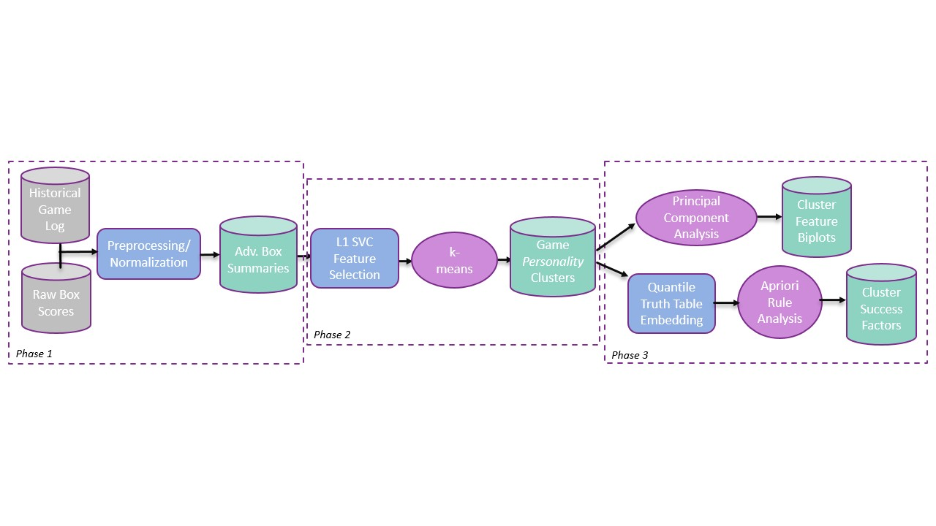

Prior NBA clustering research has centered on play-action [2], player archetypes [3], and historical eras [4]. To the best of our knowledge, this is the inaugural exploration of game personality clustering.

**Feature Selection & Clustering**

The L1 SVC feature selection algorithm aided in pinpointing relevant data attributes from advanced box-scores spanning the 1996-2023 NBA seasons. Utilizing k-means clustering on normalized numeric features, the analysis, guided by elbow plots and silhouette scores, identified an optimal cluster set of 4.

**PCA & Association Mining**

In this study, Principal Component Analysis (PCA) simplifies and visualizes a multidimensional NBA game dataset in a two-dimensional space to bolster clustering analysis and unveil inherent patterns. Next, statistical categories were divided into quantiles, forming a truth-table with rows representing games and columns indicating if a category's quantile threshold was met. Organized by cluster, this data was fed to the apriori algorithm to discern success factors impacting winning.

**3. Results**

**Clusters**

The four game clusters were summarized into feature averages to delineate each's 'personality'. They were then tagged with colloquial NBA labels: track meet, shooting clinic, blowout, and slug fest. Notably, three clusters exhibited a positive scoring margin, reinforcing the home court advantage theory. Table 1 provides feature summaries for teams (*home*-*away*) across clusters.

| Cluster Label | Score | Field Goals | 3 Point % | Assists | Boards | Fouls | Win % |
| --- | --- | --- | --- | --- | --- | --- | --- |
| ‘Track Meet’ | 113-112 | 40.3-39.8 | .364-.359 | 23.4-22.5 | 44.6-43.7 | 23.6-24.5 | .561-.439 |
| ‘Shooting Clinic’ | 102-111 | 38.2-42.3 | .342-.428 | 22.1-26.0 | 40.7-42.5 | 17.8-19.5 | .228-.772 |
| ‘Blowout’ | 114-99 | 43.7-37.3 | .433-.326 | 27.9-21.3 | 44.6-40.4 | 18.7-17.9 | .932-.068 |
| ‘Slug Fest’ | 95-93 | 35.4-34.8 | .314-.304 | 20.2-19.1 | 45.8-44.6 | 19.3-20.2 | .596-.404 |

**Rule Sets**

Rules targeting outcomes were extracted and ranked based on lift, showcasing their impact within each personality cluster. Our unsupervised methodology, unaware of basketball rules, necessitated filtering to eliminate noise such as: Knicks outscored Lakers. The refined rules illuminate the multivariate impact of concurrent success in multiple categories, for instance, an augmented win percentage when successful 3-point shooting aligns with high steal volume. These insights, when utilized by domain experts, could furnish a strategic advantage.

**Playoff & Era Analysis**

To comprehend the game's evolution and the shifts in intensity and strategy during playoffs, data was first segregated into key demographics for separate analysis. Following Silva's delineation of Transitional (96-12) and Modern (12-current) NBA eras, games were categorized by era and further divided into regular season and playoff pools. Analysis was re-conducted to discern how trends varied across these dimensions.

**4. Conclusion**

This paper innovates in identifying key success factors within diverse personality trends of NBA games, traversing eras and contexts. We posit that this methodology bears cross-domain potential in other sports, markets, and industries, for discerning nuanced success dynamics.

**References**

[1] A. Rose, "Raptors Need to Avoid 'Slugfest' by Dictating Tempo to 76ers", *Sports Illustrated Toronto Raptors News, Analysis and More*, 2022. [Online]. Available: https://www.si.com/nba/raptors/news/toronto-raptors-slugfest-transition-offense-philadelphia-76ers-playoffs.

[2] D. Stephanos, G. Husari, B. Bennett, M. Harrisson and E. Stephanos, “Using Hex Maps to Classify & Cluster Dribble Hand-Off Variants in the NBA,” in *Proceedings of the MIT Sloan Sports Analytics Conference*, 2022.

[3] S. Kalman and J. Bosch, “NBA Lineup Analysis on Clustered Player Tendencies: A new approach to the positions of basketball & modeling lineup efficiency,” in *Proceedings of the MIT Sloan Sports Analytics Conference*, 2020.

[4] J. Rocha da Silva and P. Rodrigues, "The three Eras of the NBA regular seasons: Historical trend and success factors", Journal of Sports Analytics, vol. 7, no. 4, pp. 263-275, 2021. Available: 10.3233/jsa-200525.